John Harvey

Marine Drive Residence

2205 Lower Mall

Vancouver BC V6T 1Z4

June 15th 2013

Dr Jon Nakane

Faculty of Applied Science

University of British Columbia

2360 East Mall

Vancouver BC V6T 1Z3

Dear Dr Nakane,

Subject: Formal Design Proposal for ENPH 253

We have prepared the enclosed report, titled *Brute Force and Ignorance: a Design Proposal for the Construction of an Autonomous Tape-Following and Ball-Throwing Robot*, in response to your request for a formal report, as an assignment for ENPH 253.

The report details our plans for the construction of a robot intended to compete in the 2013 ENPH 253 robot competition, including complete circuits, mechanical design, proposed software design, and an analysis of risks, individual responsibilities, and list of tasks to be accomplished.

We hope that this report will meet with your approval. If you have questions or require additional information, please contact John Harvey at [johnharveybc@gmail.ca](mailto:johnharveybc@gmail.ca).

Respectfully submitted,

John Harvey

Liam Hodgson

Rowan Walsh

Scott Lawson

Enclosure

**Brute Force and Ignorance**

A Design Proposal for the Construction of an Autonomous Tape-Following Ball-Throwing Robot

John Harvey 29240116

Liam Hodgson 29154119

Rowan Walsh 30817118

Scott Lawson 34359117

June 16th, 2013

# Abstract

This report summarizes the design of a two wheeled robot capable of competing in the 2013 ENPH 253 robot competition. The robot is designed to collect squash balls and shoot them at targets as accurately and quickly as possible. In accordance with the competition rules, the robot is designed to fit inside a 0.027 m3 cube and operate autonomously for at least 90 seconds. The robot will be able to follow tape at up to 0.8m/s and shoot squash balls at 5-8m/s.

A lightweight spinning brush sweeps balls into a holding ramp for collection. The robot has two rear wheels that can be independently steered by two servo motors and two ball casters mounted at the front. This wheel configuration allows the robot to navigate with differential steering as well as granting the ability to strafe horizontally against a wall. Several chassis mounted reflectance sensors are used for navigation, by tracking electrical tape on the play surface.

The robot is controlled by an ATMega128 based Wiring board using code written in the Wiring language and Wiring IDE.

Contents

Abstract ii

Table of Figures.......................................................................................................................................v

Glossary..................................................................................................................................................iv

1.0—Introduction 1

1.1—Overview of Basic Strategy 1

2.0—Mechanical Components 2

2.1—Chassis 2

2.1.1—Brush Mounting Structure 2

2.1.2—Brush Holders 2

2.1.3—Ball Guard 3

2.1.4—Omni-Bearings 3

2.1.5—Internal Ball Routing 3

2.1.6—Mass Budget 3

2.2—Brush 3

2.3—Firing Mechanism 4

2.3.1—Rollers 4

2.3.2—Lifting Mechanism 5

2.3.3—Tuning of the Firing System 5

3.0—Electrical Systems 7

3.1—Sensor Systems 7

3.1.1—Reflectance Sensors 7

3.1.2—IR Sensors 7

3.1.3—Touch Sensors 8

3.1.3—Sensor Cable Routing 8

3.2—Electrical Design 8

3.2.1—Sensor Circuits 8

3.2.2—Drive/Power Circuits 9

4.0—Software Code and Algorithm 11

4.1—Algorithm Overview 11

4.1.2—Locating Tape 11

4.1.2—Tape Recovery 12

4.1.3—Tape Following 13

4.1.4—Ball Collection 13

4.1.5—Wall Following 13

4.1.6—Target Acquisition and Shooting 13

5.0—Meta-Analysis 15

5.1—Team Responsibilities, Major Milestones, and Timeline 15

5.1.1—Team Responsibilities 15

5.1.2—Major Milestones 15

5.1.3—Timeline 15

Table of Figures

Figure 1. Chassis assembly 2

Figure 2. Firing mechanism roller 4

Figure 3. Lazy Susan bearing 6

Figure 4. Mars Rover wheel assembly 6

Figure 5. LM311 comparator circuit. 7

Figure 6. IR detector filter/amplification circuit 7

Figure 7. Table of circuits/protoboards 9

Figure 8. Rough wire and protoboard placement 10

Figure 9. Robot control state diagram. 11

Figure 10. Shooting algorithm flowchart 14

Figure 11. Flowchart of robot assembly dependencies 16

Figure 12. Risks, probabilities, and impacts 17

Figure 13. Decisions and deadlines 17

Glossary

**Differential** **drive**: system for moving an object using two wheels. The wheels rotate at different speeds instead of pivoting to turn, allowing for on-the-dime turns.

**Finite** **state** machine: a system that exists in one of a finite number of states, that also defines the transitions to between said states.

**H-Bridge**: circuit that allows for the reversal of current through a motor, allowing the motor to reverse.

**PID**: acronym for proportional-integral-derivative. A feedback method of correcting for error to consistently output a desired behaviour. Used in this instance to allow the robot to follow tape.

**Potentiometer**: variable resistor. The value of the resistance can be adjusted by rotating a knob or moving a slider.

**Protoboard**: thin board with a grid of holes. Electronic components can be inserted and soldered to the board, allowing for easy electronics prototyping.

**Pseudocode**: outline of computer code designed to be easily understood by a human, and not written in any programming language, which retains many of the basic elements of computer code—i.e. formatting, brackets and loops.

**QRD**: electronic component that detects the reflectance of a substance placed in front of it using infrared LEDs.

**Servo**: variety of motor which, instead of rotating at a fixed velocity, rotates to an angle between 0 and 180 degrees.

**TINAH:** acronym for ‘**T**his **I**s **N**ot **A** **H**andyboard’. Serves to control and interpret the signals sent by the robot. The device which has computer code loaded onto it. The ‘brain’ of the robot.

**VCC**: the ‘high’ voltage input of a circuit.

**Waterjet**: device that cuts nearly any material using a jet of high-pressure water

# 1.0—Introduction

The goal of the 2013 Engineering Physics robot competition, and the purpose of the robot detailed in this report, is to acquire and fire squash balls at eight targets over the course of 90 seconds within 3 m2 playing field, without any outside assistance. This report is intended to serve as a method of soliciting feedback from the instructors and TAs of ENPH 253, and plans for the construction of said robot.

In each section detailing a mechanical system (firing mechanism, chassis, etc.) the materials, dimensions, fabrication process, and method of assembly have been included, culminating in a step-by-step description of the function of the part. Rough calculations (force required, weight, speed) have been provided where appropriate. The chassis section includes the method by which each component will be fastened to the robot, as well as a description of how the balls will be moved from the collection mechanism and prepared for firing.

The electrical design and sensor system sections include detailed descriptions of the circuits involved in each: schematics and proposed methods of cable management, in particular. The sensor system section additionally includes a diagram of all sensors in relation to the TINAH board, with expected input/output values, and the electrical design section includes a list of each protoboard/PCB to be used, with approximate size, number of connections, and physical location.

Potential issues as well as solutions and alternative methods of accomplishing tasks are included in the risk management and contingency planning section. Probabilities have been estimated and assigned to each problem, as well as impact and changes to the project each would cause.

The task list, major milestone, and team responsibilities section is relatively self-explanatory. A proposed timeline, list of each team member’s main areas of responsibility, and breakdown of the interdependencies of the tasks has been included.

## 1.1—Overview of Basic Strategy

The basic strategy or the robot is fairly low-level, working from the idea that the simplest ideas are the easiest to implement successfully. The robot will initially acquire tape, move to the back of the arena, and collect balls by forcing the collecting wheel into the wall. After collecting, the robot will reverse, spin 180 degrees, and ‘wobble’ back and forth while moving forward until it acquires tape. At this point, it will advance until it reaches the end of the tape, and continue forward (no longer following tape) until it comes into contact with the front wall. It will then maneuver so that the front of the robot is perpendicular to the targets.

At this stage we rotate our wheels, so that without having moved the chassis of the robot, we can move side-to-side in front of the targets. Each time a target is detected with both of our 1000 Hz detectors, the robot will stop and fire a ball. This ball, ideally, will be collected after firing. After a small delay to allow for ball collection, the robot will continue to move sideways, repeating the process at each detected target. When the robot reaches the opposite wall, detected by one of the side-mounted touch sensors, it will reverse direction. If and when it runs out of balls, it will continue in the direction it was moving until the rear-mounted QRD sensors indicate that the robot is directly in front of tape. When this happens, it will reverse, rotate, acquire tape, and proceed to collect more balls in the same manner as previously described.

# 2.0—Mechanical Components

Contained within this section is a description of each primarily mechanical system contained within the robot: the chassis, firing mechanism, collection mechanism, drive system, and internal ball handling.

## 2.1—Chassis

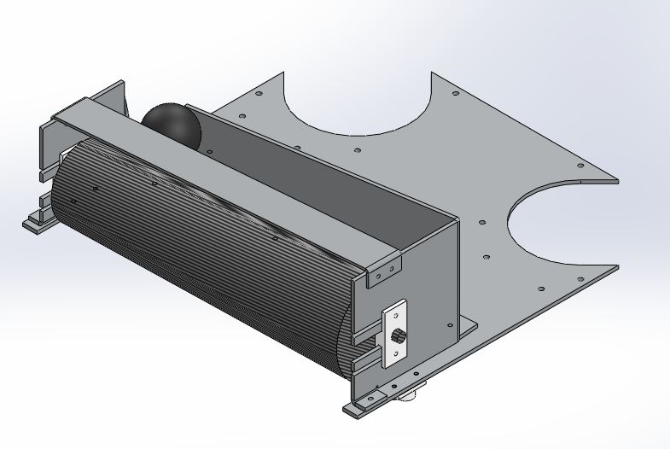The main characteristics desired in the chassis were simplicity, rigidity and modularity, as it is the structure on which the rest of the robot components are mounted. The base of the chassis consists of a flat rectangle of 3mm aluminium sheet metal, with arms extending forward, leaving a gap for the brush. 3mm aluminium provides enough stiffness for our requirements, and allows us to add threaded holes to the chassis. Clearance and tapped holes will be cut in the base to allow for rapid mounting of components, and two large holes are located near the rear corners of the chassis for the wheels, where the drive system will be located. This part will be fabricated using the waterjet, and the majority of mounting will be done using M3 screws, using the threads in the chassis, or the clearance holes and nuts. Making the base out of a single flat piece means that it is possible to add additional holes after the initial fabrication if need arises.

### 2.1.1—Brush Mounting Structure

The second part of the chassis is a structure for mounting the brush. This is also made of 3mm aluminium, and the wall behind the brush is used for ball collection. The chassis was divided into two major parts to simplify fabrication (fewer sheet metal bends required) and to allow for independent development and testing. At current, the brush and ball collection mechanism can be assembled and tested separately from the main chassis, which will have the TINAH, the sensors and motors mounted on it. This allows testing of the robot’s movement and sensing without having mounted the collection mechanism, and vice-versa. The brush mounting structure will be waterjet cut, and the flanges and two holding arms will be bent. While the two arms are bent to an angle just under 90o, there is sufficient flexibility in the design that the error which is likely to be present in our fabrication will not affect its effectiveness.

Figure . Chassis assembly

### 2.1.2—Brush Holders

Two brush holders act as an interface between the brush shaft and the chassis. Designed to allow for easy removal of the brush assembly from the chassis, they will modified frequently in testing. These components will be 3D printed, as they contain angles which would be difficult to machine. The idea it that the holders will slide onto either end of the brush shaft, and the holder will then slide into the slot cut in the vertical sheet metal brush mounting structure. This allows for flexibility in the horizontal position of the brush shaft. Once the correct location has been determined, the screws at the top and bottom the part will be tightened, clamping the upper and lower arms against the chassis structure and preventing sliding. To remove the brush, one needs only to loosen the screws and slide the entire assembly out of the slots.

### 2.1.3—Ball Guard

A ball guard will be mounted above the brush, connected to each end to the chassis using screws. Its purpose is to prevent balls being conveyed along the top side of the brush from escaping the robot. It will be made of waterjet or hand-cut aluminium sheet metal, and bent at the ends. In testing we observed that it is possible (though unlikely) for a ball to be caught between this guard and the brush, forced into the inside of the brush. The geometry of the ball guard will evolve as we test to prevent this.

### 2.1.4—Omni-Bearings

The robot will be driven by two powered wheels at the rear of the chassis. It will also have unpowered bearing wheels near the front of the robot. The bearings will be held in 3D printed holders with space for small (about 1cm) diameter ball bearings. The printed part will be screwed into the bottom of the chassis, allowing the bearing to roll freely between the printed holder and the sheet metal chassis.

### 2.1.5—Internal Ball Routing

A ramp which transports balls from the collector to firing mechanism will be made of sheet metal and riveted together. The design of this component has yet to be finalized, as it seems simple to design, and is dependent on the final structure of the firing loading mechanism and location.

### 2.1.6—Mass Budget

Base Chassis Structure (aluminium) – 460 g

Brush Mounting Structure (aluminium) – 370 g

Brush (wood, fishing line, aluminium) – 30 g

2x Brush holder (ABS) – 13 g

3x geared Barber Coleman motors – 546 g

1x ungeared Barber Coleman motors – 142 g

2x servo motors –72 g

TINAH – 235 g

Mounting – 500 g

Electronics – 250 g

Total: 2564 g

## 2.2—Brush

The brush is the most important component of the robot’s ball collection mechanism. It spins at low speed, pulling in any balls that it encounters, lifting them up a vertical wall and funnelling them towards the storage and firing mechanisms.

The brush consists of two disks of different diameters (80mm and 60mm) mounted axially on a shaft 260mm apart. The two disks have inward-facing T-slots cut at equally spaced intervals around the outer diameter, which are strung with fishing line. The fishing line passes back and forth between the slots on both disks, forming a long cylindrical surface with which to grab and pull in balls. Fishing wire was chosen as it is lightweight with a high tensile strength—very important, as each loop is tensioned between the end disks. Fishing wire is also flexible, allowing it to deform inwards when it is rolling over a ball – this allows us to leave a gap smaller than the ball diameter (approximately 20-30mm for a 40mm ball) between the ground and the outer diameter of the brush. Testing has shown that the brush will easily pull in a ball and push it up the vertical wall behind the brush. Further testing will need to be done to determine the optimal spacing between the brush and floor/wall, as well as which surface finish will provide appropriate friction between the ball and vertical wall, to allow the ball to be moved up. The spacing of the strung wires is such that balls should not pass through the string into the interior of the brush: however, an inner tube may be added if testing showing that this intrusion is a possibility. In the prototypes fabricated so far, the brush has been strung with a single length of fishing line. This presents a risk, as if one section of the line breaks, the entire brush will be rendered useless. To overcome this, we are considering stringing the brush with multiple, shorter lengths of fishing line, or stringing the entire brush with a several overlapping lengths of fishing wire. Another property of fishing wire is that it is fairly slippery—balls will not jam against it. This, combined with the unequal wheel diameters, allows us to uniquely transport balls. Extending the vertical wall (up which the ball is pushed) above the brush allows the balls to roll between the top of the brush and the wall, similar to lumberjacks walking backwards on floating logs. Due to the slope of the brush, it will be roll along the top of the brush towards one end. When this end is reached, they will leave the collection mechanism and roll down a ramp through a hole in the back wall. The brush is constantly rolling, which allows for multiple balls on top of the brush at once: they will not jam together, which was a concern when using a static ramp or brush.

The size of the brush has been determined based on various constraints. The final dimensions will be finalized after more extensive testing. The maximum brush diameter is 130mm: if the brush is any larger than this, the wire cannot contact balls resting against the rear wall. The minimum diameter of the wheel is harder to calculate. We intend to minimize this dimension, as it leaves more space for other components on the chassis. The difference between the two disk diameters, which creates the slope for the ball to roll down, can be relatively small. When tested, a 20mm difference in diameter was adequate to produce the action required.

The brush will be driven by a belt running around the end of its shaft, leading to a drive motor mounted behind the vertical wall. A flexible belt allows the axes of the brush and motor shaft to be at an angle to each other and still transmit rotation, as will be the case.

The brush will be mounted at the front of the robot between the two arms of the brush mounting structure. Preliminary prototypes have used disks made using laser cut wooden disks constrained with nuts on a threaded rod. Metal disks are being considered, due to its higher strength; however, this will increase mass and the chance that the fishing wire will be cut by sharp edges.

## 2.3—Firing Mechanism

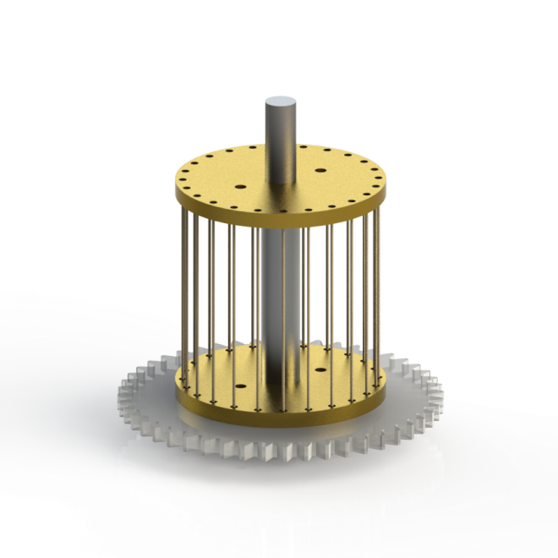The firing system uses two rollers, spinning in opposite directions. The rollers use a similar design to the ball-collector brush: strings strung between two plates with holes along their circumferences. The rollers driven by a single motor and are geared together, ensuring both spin at the same rate. The ball is lifted from a ramp below the firing mechanism into place between the rollers by a servo-actuated arm.

### 2.3.1—Rollers

The firing system consists of two rollers spun in opposite directions by an ungeared Barber Coleman motor. The rollers consist of two separated plates with strung similarly to the collection wheel. It was observed in tests of the collector mechanism that string provides excellent grip, by deforming to the shape of the object exerting force on it. The string used for the firing rollers will be Kevlar Size 5 thread, with an approximate breaking strength of 600 N, which is more than adequate. To minimize friction between the rollers and the stationary axle, the plates will be cut from brass. This will increase the weight of the assembly, but will provide most of the energy when firing a ball: the motor's energy will be stored in the angular momentum of the discs.

Figure . Firing mechanism roller

An ungeared Barber Coleman motor is used, as it can provide a higher maximum speed. Assuming a 5 m/s exit velocity of the ball and 50 mm diameter rollers, the discs will need to be spun to about 1900 rpm. A 1:1 gear ratio between the two rotors will ensure that their speeds are exactly synchronized, which is important for firing the balls in a consistent direction. 3D-printed guides will constrain the balls vertically between the rollers, away from the gearing.

### 2.3.2—Lifting Mechanism

Once balls have been collected, they are corralled into a line below the firing mechanism. This line ends with the next ball to be fired sitting in the hollow of a servo-actuated arm. A reflectance sensor within this hollow confirms the presence of a ball before firing. The arm lifts the ball into the gap between the rollers; once the ball makes contact with the roller's strings, it is accelerated towards the targets.

### 2.3.3—Tuning of the Firing System

Calculations can be done to obtain rough estimates for the roller diameter and speed, but as any friction and play in the physical mechanism cannot be fully taken into account, tuning the system will have an important role in determining its final configuration. The design of the firing system's structure takes this into account: slots have been added to adjust the angle of the entire firing assembly relative to the chassis, and the ball-lifting system will be able to lift balls to a range of heights.

In particular, firing speed will need to be carefully tuned. The possibility of targets bouncing back from an "away-flipped" state after being hit by a ball limits the exit velocity, while the need to consistently hit targets hard enough to flip them sets a lower bound.

## 2.4—Drive System

The design of the robot's drive system addresses its need to steer while moving forwards and strafe laterally along the target wall.

### 2.4.1—Differential Rear Wheel Drive

While the robot is following tape and tracking an IR beacon, it is advantageous for it to use rear differential drive to turn and steer. With reflectance sensors for the tape placed towards the front of the robot, the distance between the centre-of-steering and the tape-sensors is maximized; this leads to faster and more accurate tape-following.

However, with the centre of steering placed towards the rear of the robot the moment of inertia around this point will become trickier to minimize. Placing the relatively heavy firing mechanism and battery along the centre axis of the robot will help to minimize the moment of inertia.

Geared Barber Coleman motors will be used to direct-drive each wheel. These motors have a maximum torque of 20 N cm and a no-load speed of 470 rpm. If our robot is assumed to have a cruising speed of 1 m/s and 60 mm diameter wheels (as shown in the design below), the wheels will need to rotate at 318 rpm. Neglecting the robot's purposeful movement for a moment, and assuming a maximum weight of 5 kg, the torque on the wheels due to the robot's weight on a sloped is about 7 N cm. This estimate of the cruising speed and torque for this motor and wheel combination places our robot comfortably within the "Green Zone" of efficient motor operation.

### 2.4.2—Strafing

In order to quickly traverse along the row of targets, the robot will strafe along the top wall of the arena, stopping to fire and re-collect when an un-flipped target is detected. In order to strafe, the rear wheels and their driving motors are rotated 90 degrees about the vertical axis until they are parallel to the wall, in a fashion similar to the wheels of the Curiosity Mars rover. The angle and speed of the wheels may then be adjusted based on the wall-detecting sensors so that the robot maintains an accurate course.

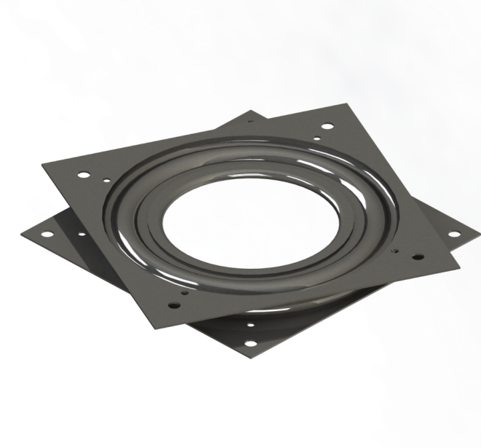A challenge faced in this design was isolating the servo or motor responsible for rotating the wheel drive assembly from any forces applied to the wheel as the robot accelerates around the arena. At the same time, the angular actuation had to be accurate and repeatable. These design points were met with the use of turntable, or "Lazy Susan", bearings.

Since these bearings rotate along the edge of a circle, instead of around an axle, the chance of binding under shear forces is much reduced. The wheel and its drive motor are mounted on the upper rotating plate while a small wheel diameter can be used due to the bearing's thin profile. As seen in the model below, a servo is geared to provide angular actuation of the wheel drive assembly while remaining isolated from any forces applied to the wheel. Moments about the bearing's vertical axis are still applied to the servo, however with a gear ratio of 5:8 and a holding torque of 42 N cm, the servo will be able to hold a maximum moment 67.2 N cm.

Figure . Lazy Susan Bearing

If these moments (and the holding current drawn by the servo due to them) become a problem, extra friction can be introduced to the system to the gearing system. While the servo can overcome this friction when it is turning the drive assembly, the friction will take a portion of any applied moments when the drive system is not rotating.

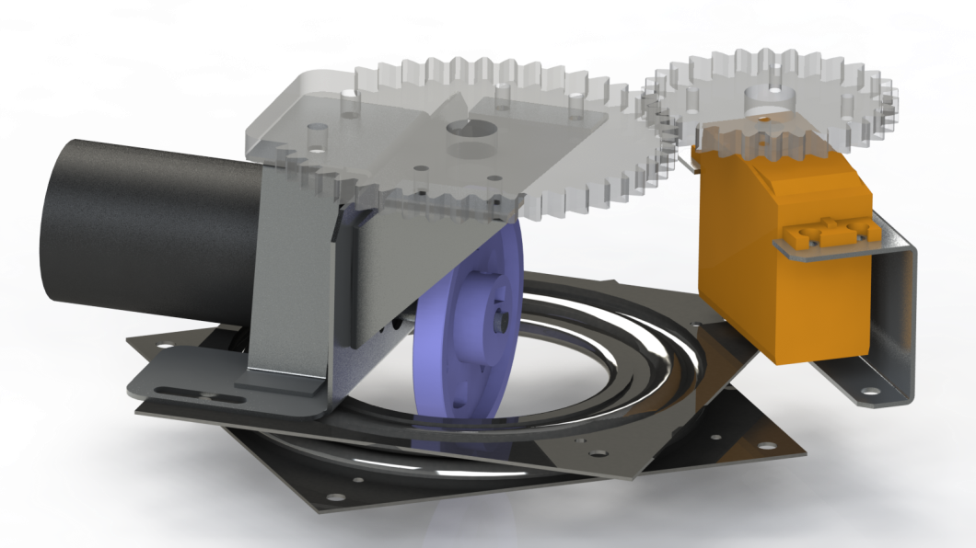

Figure . Mars Rover Wheel Assembly

# 3.0—Electrical Systems

Contained within this section is a description of the electrical systems contained within the robot: the sensor array and basic electrical design—inputs and outputs into the main board, PCBs, and voltages/power provided.

## 3.1—Sensor Systems

The sensor system consists of three varieties of sensors: touch, IR light, and reflectance. The touch sensors serve to align the robot with the front wall when firing at targets, and indicate when the robot is at the end of a wall. The IR light detectors are primarily used in acquiring targets, but a 10 kHz sensor has been included as a contingency measure, if other methods of orientation should fail. Five reflectance sensors are used to follow tape, and one is used to detect whether the robot has balls ready to fire. While the signals will be routed to the TINAH board, the sensors will draw their power from two 9V LiPo batteries.

### 3.1.1—Reflectance Sensors

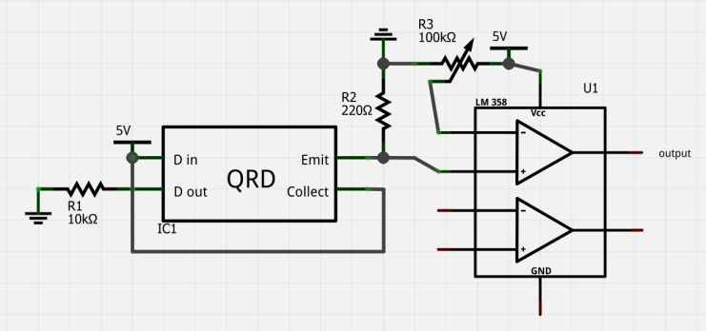Each reflectance sensor will be attached to an LM311 comparator and a potentiometer. This will allow the reflectance sensors to output a digital signal (the input voltage compared to the voltage across the potentiometer) reducing the number of analog pins required by six, and allowing a relatively stable digital signal to be sent to the TINAH board, as opposed to an analog signal, which would require shielding. Four of the sensors will be mounted on the front of the robot—two near the middle, and one at each side. The two near the middle will be used for following tape, and the two on the sides will be used to detect the T-shaped end of tape near the targets. One sensor will be towed behind the robot, used to sense when the robot is directly in front of tape, allowing us to reverse directly onto tape from firing and collecting, as opposed to having to re-acquire tape blindly. The final reflectance sensor is internal, and used to sense when a ball is in the loading mechanism. Our intention is to replace the potentiometers with fixed-value resistors after calibrating them to sense tape/ball, as appropriate.

Figure . LM311 comparator circuit. The LM358 IC is supposed to be an LM311.

### 3.1.2—IR Sensors

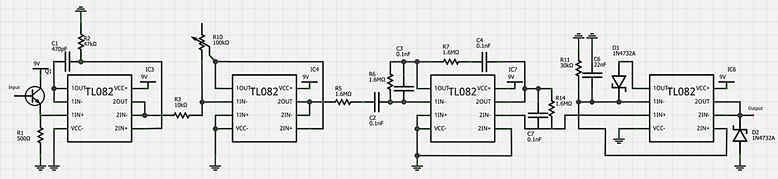The IR light detectors are the most complicated sensor. Each requires ten circuits: a detector, DC filter, amplifier, two active filters, a rectifier, and four unity-gain amplifiers. Our intention is to leave each of these as discrete circuits, as opposed to combining several in one. This is to ensure that debugging and tuning are relatively easy. Two of the sensors, mounted facing the front, will detect 1 kHz IR light at a distance of one foot, allowing us to aim at targets. The third will detect 10 kHz light at a variety of distances (achieved by splitting the detected signal between two amplification circuits designed for ranges of 1-3 and 4-6 feet) and will be used as a last-resort method of re-orienting, as well as a method of finding the back wall to collect balls. The two 1 kHz sensors will be mounted six inches apart, to minimize overlap between individual targets.

Figure . IR detector filter/amplification circuit

### 3.1.3—Touch Sensors

The four touch sensors are, at this stage in planning, somewhat in flux. The initial plan is to use digital touch sensors—buttons. One sensor will be mounted on each side of the robot, used to detect when a wall has been reached. The front sensors, while initially planned to be digital switches, might evolve into more complex analog sensors if we find ourselves unable to follow the wall effectively with digital sensors. This would be accomplished by moving the bearings on the front of the robot to metal ‘whiskers’ attached to springs which rotate as the bearings come into contact with the wall. Their rotation will be transformed into a measure of how hard we are pressed into the wall, allowing us to more accurately sense whether or not we are perpendicular to the wall. If it is possibly to use a PID algorithm to stay perpendicular to the wall using digital touch sensors, this will not be necessary, but we see no easy way to test this until our robot is moving.

### 3.1.3—Sensor Cable Routing

Cables leading from the sensors and to the TINAH board and batteries will be collected and routed as a single entity wherever possible, as opposed to routing individual wires. We intend to use ribbon cable as frequently as is possible, and to have the battery inputs for all our circuits as close to the TINAH board as prudent, to ensure that the cables remain grouped as long as is possible. Our intention is to route cables from the four QRD circuits at the front in conjunction with the touch sensor cables, simplifying the wiring of the majority of the components located away from the robot’s core. Each tape sensor has three inputs (VCC, ground, and signal) and each touch sensor, two, bringing us to a total of 20 wires required. 24-conductor ribbon cable will be routed from the circuit which interprets the QRD signal to a permanently mounted shrouded box header on the battery/TINAH interface board.

The three IR sensors will be routed similarly, using three three-wire insulated cables, tied together and routed to a permanently mounted connector on the TINAH/battery interface. The trailing tape-follower and internal reflectance sensor will be routed as a unit.

## 3.2—Electrical Design

The circuits used in the robot can be broken into two categories: sensor, and drive/power. The circuits which interpret (compare, filter) the sensor signals will be placed near the sensors themselves, and other circuits, such as the H-bridges used, will be placed near the TINAH board. The batteries will be placed as close to the TINAH board as possible. No cable will interface directly with the TINAH board: all cables will go through a permanently mounted circuit board which has leads to battery outputs and TINAH inputs.

### 3.2.1—Sensor Circuits

The comparators for the reflectance sensors used to follow tape at the front of the robot will be mounted behind the larger-radius wheel, on the right of the robot. This board will contain 4 LM311 comparator chips, and several resistors. It will be approximately 60 by 25 mm, and mounted sideways, parallel to the side of the chassis. Removing and replacing the circuit will be as easy as pulling it out—it will be held in place loosely and constrained by two bolts during the competition itself.

The touch sensors require no circuit to interpret their signal. They will be connected via header pins on the reflectance sensor interpreter board, which has a 24-conductor ribbon cable as its only link to the TINAH/battery interface.

The internal reflectance sensor (used to determine whether or not the robot has a ball to fire) and trailing tape follower will be routed to the TINAH/battery board as compactly as possible. This is expected to be simple, given their close proximity to the board.

The IR sensors will be individually routed to the TINAH board/battery via shielded cables. The two 1 kHz wires will be twisted together before joining the sensor ribbon cable and moving back towards the TINAH board. The 10 kHz cable will be routed alongside the trailing tape follower cable.

### 3.2.2—Drive/Power Circuits

The two H-bridge circuits will be enclosed in a bent sheet-metal box (approximately 60 by 120 by 40 mm) kept close to the TINAH board. The inputs to the H-bridges will come from the TINAH board/battery board, and the outputs will move to snap-fit connectors, leading to the motors. All of the servos (two wheel-rotation, one loading mechanism) will go directly to the TINAH/battery interface board. The remaining Barber Coleman motors (collector and firing mechanism, geared and ungeared, respectively) will also go to the TINAH/battery interface board directly, as neither requires an H-Bridge.

A long, thin protoboard will be placed directly above the TINAH board, serving as a TINAH board/battery interface. All wires from sensors and motors will plug into this board, as opposed to the TINAH board itself. It will provide various voltages (5V, 9V, and 12V) and be permanently, rigidly mounted. It will have a variety of inputs, from single wire to ribbon cable, and route the appropriate inputs/outputs from the TINAH board to the cables plugged into the battery/board interface, making unplugging and replacing/debugging individual sensors/motors easier.

|  |  |  |  |
| --- | --- | --- | --- |
| Name (quantity, size) (pins) | Function | Input/output values | Comments |
| H-bridge (1, 60x120)  Input pins: 12V, ground, 2 TINAH PWN  Output pins: 2 battery PWM | Locomotion motor inputs/outputs | Inputs: 12V, ~1.3 A (max) Outputs: 12V ~1.3 A (max) | Enclosed within a metal box, 40 mm tall. Cables to motors are three-strand shielded wire |
| TINAH board/battery interface (1, 15x150) Input pins: Battery ground, 5V, 9V, 12V, various sensors Output pins: VCC and ground, sensor data (to various TINAH inputs) | Provides a single interface for connecting inputs/outputs requiring both TINAH and battery. | Three rails of outputs/inputs (VCC, ground, signal) and three rails of constants (5V, 9V, 12V) | Mounted close to/over TINAH and battery, near back of robot. Signal rail is not continuous, and has individual wires leading to TINAH inputs |
| Reflectance sensor interpreter (1, 25x60) Inputs: 4 QRD outputs, 4 touch outputs Outputs: 4 9V/ground (QRD), 4 touch inputs (5V) | Four LM311 comparators, and touch sensor to ribbon cable inputs. | Inputs: Front tape-following sensors (5V, 40mA) touch sensors (5V) Outputs: compared (digital) tape-following signal (5V), touch sensors (5V) | A single ribbon cable comes from this board and is routed to the board/battery interface. It includes touch sensor and compared tape sensor outputs. |
| IR sensor filter (3, 75x25) | Amplifies and filters 1 kHz and 10kHz IR inputs. | Inputs: IR light, 9V, ground Outputs: 0-5 volts | Stored in bent sheet-metal boxes, mounted 6 inches apart, centered above the brush. Outputs are sent via shielded cable. |

Figure . Table of circuits/protoboards

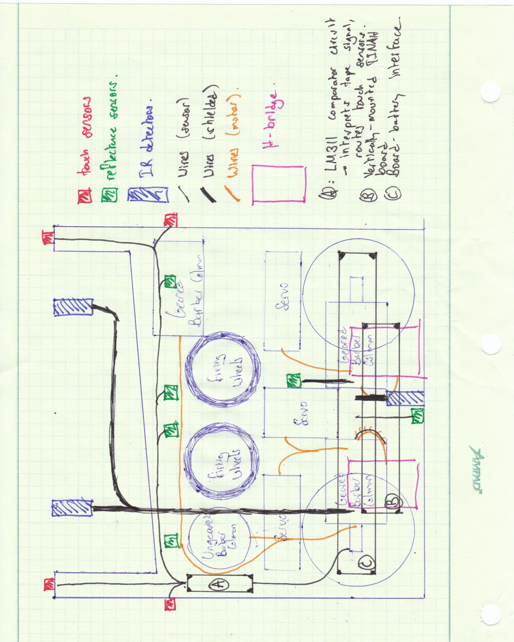

Figure . Rough wire and protoboard placement: not to scale

# 4.0—Software Code and Algorithm

The robot controller is the ATMega128 based Wiring board with a TINAH shield. The Wiring board runs programs created using the Wiring language and Wiring IDE.

## 4.1—Algorithm Overview

The robot is modelled as a finite state machine. The highest level states are tape following, collecting, wall following, and shooting. The tape following state is central since it facilitates transitions between the collecting and wall following states. If the robot is disoriented at any point, this state provides moderate failure recovery since the robot can realign with the nearest tape. Shown below is the robot’s high level state diagram.

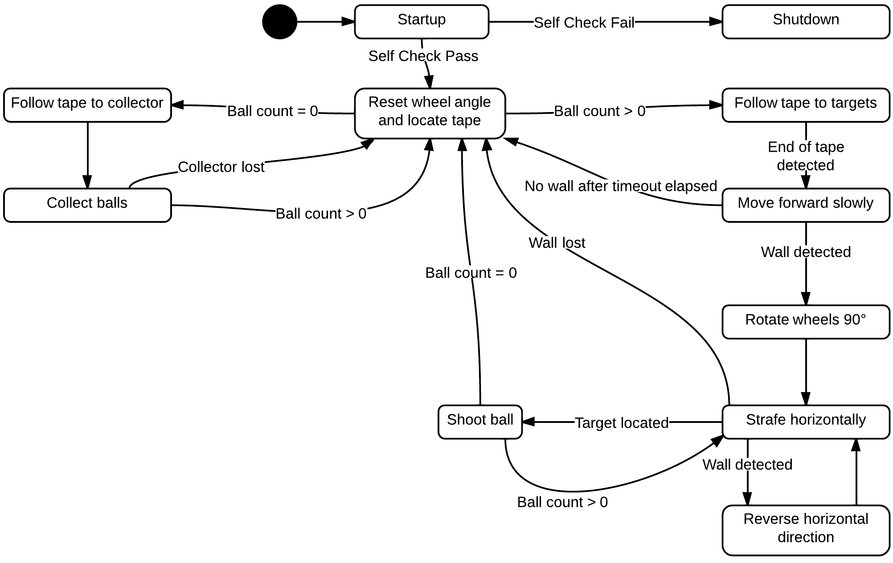

Figure . Robot control is implemented as finite state machine.

### 4.1.2—Locating Tape

The QRD sensor mounted on the tail permits tape detection while following the front wall. By counting the number of tape detections, it is possible to locate the centre tape. The below pseudocode provides one possible implementation of the centre tape algorithm. Since QRD readings are sampled dozens of times per second, it is important to note that this algorithm only counts *changes* in tape state. That is, it only detects tape when the previous reading did not detect tape. This ensures that each strip of tape is only counted once.

|  |
| --- |
| // PRE: Start facing target wall  // POST: Stopped with rear QRD sensor on centre tape  void LocateCenterTape()  {  Strafe(LEFT);  while(!LeftTouchSensor()) // Wait for left wall alignment  Update();  Strafe(RIGHT); // Start moving right  int tapeCount = 0;  while(tapeCount < 2) // Look for centre tape  {  // Prevents same tape from being detected twice  if (TapeRiseDetected()) tapeCount++;  else Update();  }  StopMotors(); // Stop at centre tape  } |

Once the tape has been located, the next step is to move the robot onto the tape. This will be accomplished by reversing, and rotating the robot until the front mounted QRD sensor has detected the tape. The following pseudocode demonstrates this manoeuvre.

|  |
| --- |
| // PRE: Situated on tape  // POST: Situated on tape, but rotated 180 degrees  void RotateOnTape(int turnRate = 100, unsigned int timeout = 10000)  {  SetWheelAngle(0);  LeftMotor(turnRate);  RightMotor(-turnRate);  while(!FrontTapeDetected())  {  Update();  if(timeout <= 0) TapeRecovery();  else timeout--;  }  StopMotors();  } |

### 4.1.2—Tape Recovery

If the tape is unexpectedly lost and can’t be immediately recovered, a tape recovery algorithm will be called. This algorithm will cause the robot to move in an expanding spiral. This ensures that the tape closest to the robot will be detected first. It is a recursive algorithm that will continue looking for tape forever. It is difficult to implement a reliable tape recovery algorithm due to lack of sensor input and the limited computing power of the ATMega128. Because of this, heuristic algorithms such as the below algorithm will be considered for implementation.

|  |
| --- |
| // PRE: Sensors cannot detect tape  // POST: Moves in expanding spirals until tape is detected  void TapeRecovery()  {  int leftSpeed = -200;  int rightSpeed = 200;  int timeout = 0;  LeftMotor(leftSpeed);  RightMotor(rightSpeed);  while(!FrontTapeDetected())  {  Update();  timeout++;  // Increase spiral radius  if (timeout % 100 == 0) LeftMotor(++leftSpeed);  if (timeout < 10000) continue;  // Call again to reset spiral  TapeRecovery();  return;  }  StopMotors();  } |

### 4.1.3—Tape Following

The robot has two tape following states: one that navigates to the collector (10 kHz emitter), and one that navigates towards the targets. A standard PID algorithm, as shown below, will be implemented to follow the tape. The end of the tape on the collector side does not have a T-shaped intersection, while the target side does. Thus, the tape’s end will be detected by polling the two front-side mounted QRD sensors that act as intersection detectors.

// Computes new PID values and calculates a new motor speed for

// the left and right motors.

void Move()

{

if (leftDetected && rightDetected) error = 0;

else if (!leftDetected && rightDetected) error = TOO_LEFT;

else if (leftDetected && !rightDetected) error = TOO_RIGHT;

else if (!leftDetected && !rightDetected)

error = (previousError <= TOO_LEFT) ? -OFF_TAPE : OFF_TAPE;

float proportional = (float)error * proportionalGain;

float derivative = (float)(error - previousError) * derivativeGain;

motor.speed(LEFT_MOTOR, speed + (proportional + derivative));

motor.speed(RIGHT_MOTOR, speed - (proportional + derivative));

previousError = error;

}

### 4.1.4—Ball Collection

The ball collection manoeuvre is executed by driving the robot forward in the direction of the collector (10 kHz emitter) and butting against the wall. A QRD reflectance sensor paired with a comparator will be mounted in the ball hopper to detect successful ball collections. When a ball rolls into the device that lifts balls to the firing mechanism, the state of the QRD will change, indicating that we have ammunition. We a considering mounting a QRD sensor such that each ball will roll past it, quickly changing the state of the QRD, triggering standard hardware CPU interrupt that will increment the ball count, allowing us to know at all times how many balls we have in our robot.

### 4.1.5—Wall Following

Two front mounted contact switches indicate whether the robot is currently contacting a wall. After the robot reaches the end of the tape on the target side, it will slowly approach the wall until contact is made. When this occurs, it will rotate the rear wheels by 90°. This wheel rotation lets the robot strafe horizontally along the wall. A PID algorithm will be implemented to keep the robot aligned along the wall at all times.

### 4.1.6—Target Acquisition and Shooting

Once a ball has been collected and the robot is aligned along the target wall, it will be considered capable of firing at the targets. Infrared sensors provide analogue input to the Wiring board to indicate whether the target has already been hit. If the input voltage is above a certain threshold then a valid target has been acquired. A PWM command will tell a servo to load the ball into the spinning disks and fire.

Decision theory influences the shooting behaviour. If no targets can be detected, then either the robot’s sensors are not functioning properly or all of the targets have been hit. It is assumed that the robot is more likely to fail than it is to succeed. With this assumption, it is in the robot’s best interest to blindly fire at targets. If all targets had been hit, it implies that the robot is doing very well, thus making the deleterious effects of unnecessary firing negligible. The below flow chart provides an overview of the shooting algorithm. The *wall count* variable is used to determine whether no targets were detected. Whether or not this implemented will depend on the accuracy of the IR sensors, which will be tested.

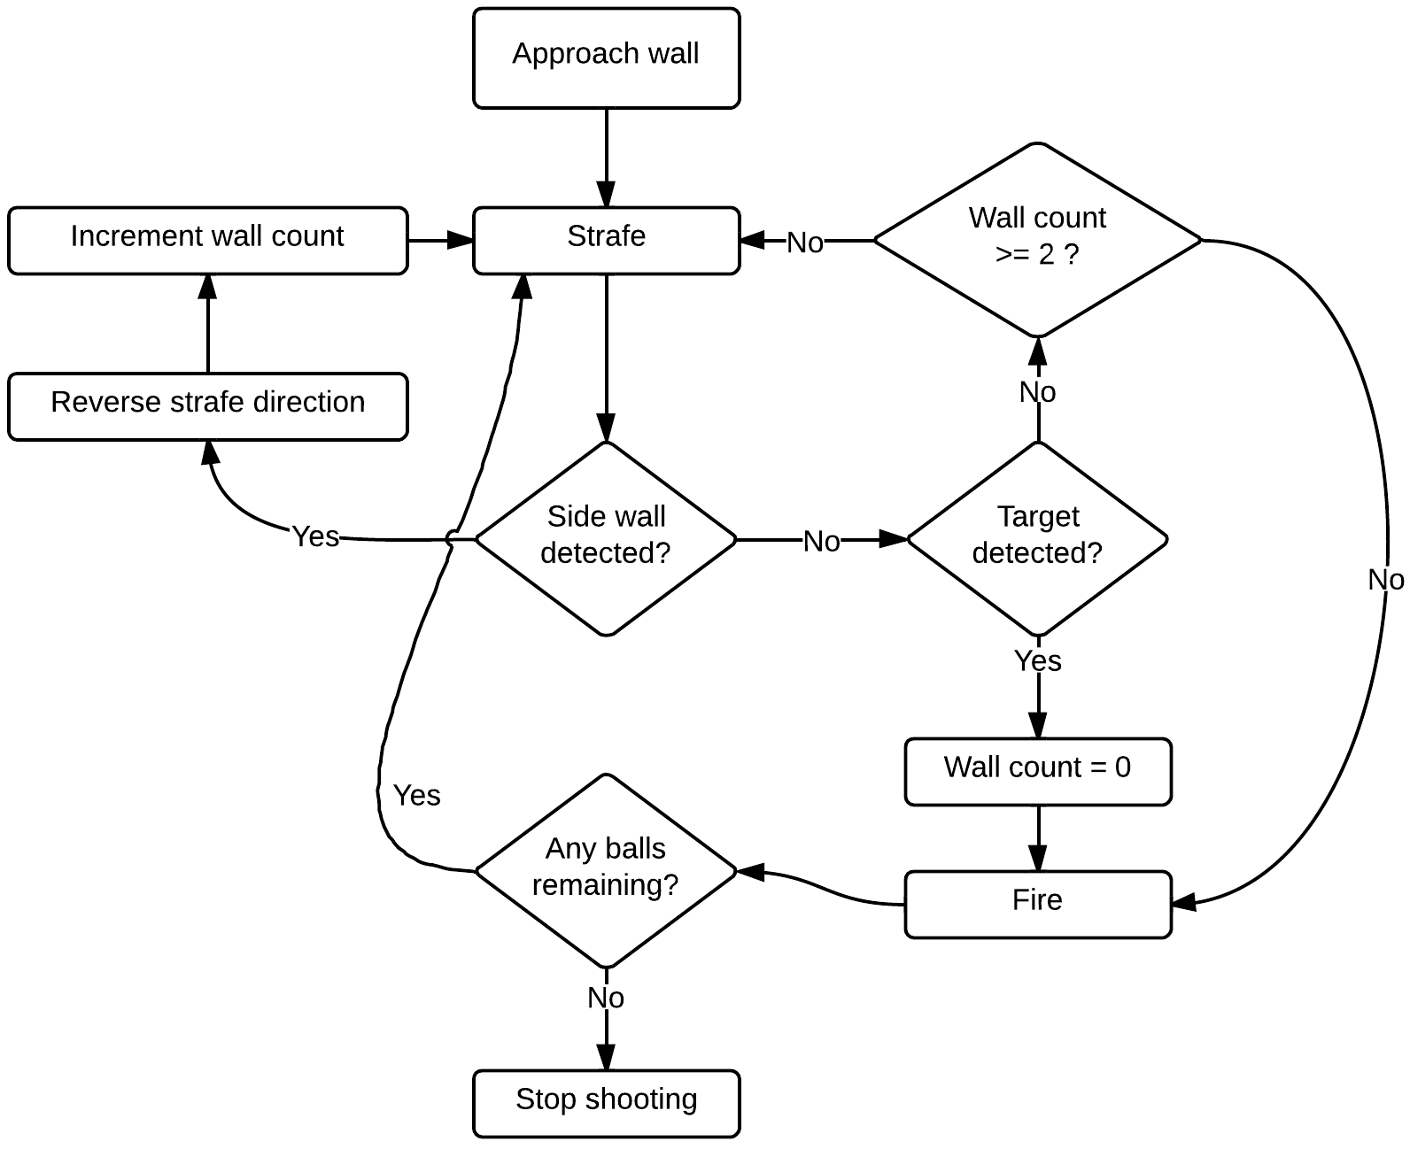

Figure . The shooting algorithm flowchart. When no balls remain, the robot stops shooting and enters a ball collection state

# 5.0—Meta-Analysis

This section pertains to the more human elements of constructing a complex system: failures, risks, timelines, and individual responsibilities are detailed in this section.

## 5.1—Team Responsibilities, Major Milestones, and Timeline

### 5.1.1—Team Responsibilities

Each team member has taken a lead role in a certain part of the robot. While all team members take part in the design, fabrication, and implementation of each sub-assembly in the robot, the lead is responsible for keeping the team informed as to the state of their section, and keeping development of their section on-schedule.

John Harvey—Electronics lead, overall organization

Liam Hodgson—Collection system and chassis lead

Rowan Walsh—Firing mechanism and drive system lead

Scott Lawson—Software lead

### 5.1.2—Major Milestones

By major milestone day (July 8th) the robot needs to be able to accomplish the following tasks

* Move
  + Chassis will be fabricated, and most electronics as well as drive system will be mounted.
  + H-bridge and other motor control circuits will be fabricated and tested.
  + Software will be written and implemented to drive motors.
* Follow tape
  + The tape following sensors will be mounted along with the comparator circuits.
  + The tape following algorithm will be implemented.
* Collect balls
  + Brush size and design will be finalized.
  + Brush will have been mounted on the chassis and connected to the drive mechanism.
  + Brush will be able to pull in balls and transport them to firing mechanism.

### 5.1.3—Timeline

The following list presents the tasks we wish to accomplish, in priority order.

1. Prototype chassis created
2. Basic electronics mounted—TINAH board, H-Bridges, board/battery interface
3. Robot moving—Mars Rover wheels implemented
4. Wall detection/following implemented

After this stage, work on tasks will proceed in parallel. In no particular order:

1. Robot following tape reliably
2. Ball collection brush functioning, routing balls to firing mechanism
3. Firing mechanism functioning
4. IR sensors functioning

The flow chart shows the major tasks to be completed, and the interdependencies of the tasks. The tasks furthest to the right of each branch do not have any dependencies.

Figure . Flowchart of robot assembly dependencies

Our goal is to have a mechanically and electrically sound robot two weeks before time trials, and spend the remaining time devoted exclusively to software. In the event that we should proceed faster than expected, extra time will be spent fine-tuning electrical systems, optimizing robot movement, and painting sweet-ass flames on the chassis.

## 5.2—Risk Assessment and Contingency Planning

This section consists of a table of risks, with associated probabilities, impacts, and changes to be made to the plan if said risk should come to bear. Also included are decisions to be made, and dates by which said decisions must be made.

### 5.2.1—Risk Assessment

|  |  |  |  |
| --- | --- | --- | --- |
| Risk Condition | Probability of Occurrence | Impact to Project | Change to Work Plan |
| Balls jam while being collected | 5% | Would disable ball collection mechanism | Redesign of ball collection system: specifically, brush and shroud |
| Balls slip off ramp | 2% | Loose ball inside robot could jam rotating wheel | Addition of a roof to the ramp area, higher side walls |
| Ball jam while loading | 10% | Firing mechanism disabled until jam resolved, potential loose ball inside robot | Redesign of loading arm/area |
| Insufficient firing torque | 20% | Balls will be unable to reach target, robot may get caught in loop of continuously re-collecting ball and firing at target | Adjust algorithm to ‘one target, one shot’. Increase motor torque/change gearing |
| Digital wall following too difficult to implement/unreliable | Impossible to estimate: requires testing | Robot cannot fire at targets reliably. | Exchange digital switches for analogue pressure sensors |
| Unable to distinguish between targets | 10% | Robot may fire at ‘incorrect’ targets | Adjust gain/filtering circuits, spacing of 1 kHz sensors |
| Rear-mounted QRD sensor proves ineffective | 30% | Robot will not know when to turn around after firing/collection | Scrap rear-mounted QRD, guess at position of tape when reversing, use 10 kHz signal, back off wall and strafe to acquire tape. |
| LiPo voltage fluctuates over the course of the competition | 2% | Irregular motor motion, slower traversal, firing speed diminished. | Use voltage regulators, adjust power consumption (deactivate unnecessary devices when not in use) |
| Crosstalk between sensor cables | 15% | Sensor signals are unreliable | Shield additional cables, convert signals to digital closer to outputs |

Figure . Risks, probabilities, and impacts

### 5.2.2—Decisions and Deadlines

|  |  |  |
| --- | --- | --- |
| **Decision** | **Options** | **Deadlines** |
| Shape of ramp | Two straight ramps, curved ramps, orientation of ramp | Major milestone day |
| 10 kHz sensor | Whether to include 10 kHz sensor, purpose of sensor | First week of July |
| Brush diameters | Various sizes: smaller is better, but how small? | Last week of June |
| Cable routing | Exact routing is still in flux | First week of July |

Figure . Decisions and Deadlines